UNITED STATES
SECURITIES AND EXCHANGE COMMISSION
WASHINGTON, D.C. 20549

FORM 8-K

CURRENT REPORT
Pursuant to Section 13 or 15(d)
of the Securities Exchange Act of 1934
Date of Report (Date of earliest event reported): September 3, 2026

CLIMB BIO, INC.
(Exact Name of Registrant as Specified in its Charter)

Delaware |  | 001-40708 |  | 83-2273741
(State or Other Jurisdiction  of Incorporation) |  | (Commission  File Number) |  | (IRS Employer  Identification No.)

20 William Street, Suite G50  Wellesley Hills, Massachusetts |  | 02481
(Address of Principal Executive Offices) |  | (Zip Code)
Registrant’s Telephone Number, Including Area Code: (866) 857-2596
Not Applicable
(Former Name or Former Address, if Changed Since Last Report)

Check the appropriate box below if the Form 8-K filing is intended to simultaneously satisfy the filing obligation of the registrant under any of the following provisions (see General Instruction A.2. below):

☐ | Written communications pursuant to Rule 425 under the Securities Act (17 CFR 230.425)

☐ | Soliciting material pursuant to Rule 14a-12 under the Exchange Act (17 CFR 240.14a-12)

☐ | Pre-commencement communications pursuant to Rule 14d-2(b) under the Exchange Act (17 CFR 240.14d-2(b))

☐ | Pre-commencement communications pursuant to Rule 13e-4(c) under the Exchange Act (17 CFR 240.13e-4(c))
Securities registered pursuant to Section 12(b) of the Act:

Title of each class |  | Trading  Symbol(s) |  | Name of each exchange  on which registered
Common Stock, par value $0.0001 per share |  | CLYM |  | The Nasdaq Stock Market LLC  (The Nasdaq Global Market)
Indicate by check mark whether the registrant is an emerging growth company as defined in Rule 405 of the Securities Act of 1933 (§ 230.405 of this chapter) or Rule 12b-2 of the Securities Exchange Act of 1934 (§ 240.12b-2 of this chapter).
Emerging growth company ☒
If an emerging growth company, indicate by check mark if the registrant has elected not to use the extended transition period for complying with any new or revised financial accounting standards provided pursuant to Section 13(a) of the Exchange Act. ☐

Item 7.01. Regulation FD Disclosure
On September 3, 2026, Climb Bio, Inc. (the “Company”) issued a press release and published a corporate presentation announcing positive results from its ongoing Phase 1 trial evaluating CLYM116, an anti-APRIL monoclonal antibody, and provided updates on its strategy for further development in IgA nephropathy.
A copy of the press release and presentation are furnished as Exhibit 99.1 and Exhibit 99.2 to this Current Report on Form 8-K and are incorporated by reference herein. The information contained in Item 7.01 of this Current Report on Form 8-K and the exhibit furnished under Item 7.01 of this Current Report on Form 8-K shall not be deemed to be “filed” for purposes of Section 18 of the Securities Exchange Act of 1934, as amended (the “Exchange Act”), or otherwise subject to the liabilities of that section, nor shall they be deemed incorporated by reference in any filing under the Exchange Act or the Securities Act, regardless of any general incorporation language in such filing.
Item 9.01 Financial Statements and Exhibits.
(d) Exhibits

Exhibit  No. |  | Description
99.1 |  | Press Release, dated September 3, 2026
99.2 |  | Investor Presentation of Climb Bio, Inc. dated September 3, 2026
104 |  | Cover Page Interactive Data File (embedded within the Inline XBRL document)

SIGNATURES
Pursuant to the requirements of the Securities Exchange Act of 1934, as amended, the registrant has duly caused this report to be signed on its behalf by the undersigned hereunto duly authorized.

 |  |  |  |  |  | Climb Bio, Inc.
Date: September 3, 2026 |  |  |  | By: |  | /s/ Aoife Brennan
 |  |  |  |  |  | Aoife Brennan, M.B., Ch.B.
 |  |  |  |  |  | President and Chief Executive Officer
Exhibit 99.1

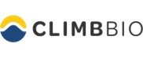
Climb Bio Announces CLYM116 Phase 1 Data Demonstrating Prolonged Half-Life and Best-In-Class APRIL Suppression Supporting Every-12-Week Dosing in IgA Nephropathy
~29-day half-life
Single 320 mg dose of CLYM116 drove near-complete APRIL suppression and 60-75% IgA/Gd-IgA1 suppression through 12 weeks
CLYM116 generally well-tolerated, with no serious adverse events, dose-limiting toxicities, or hypogammaglobulinemia
Phase 2 NAVIGATE-2 trial in IgA nephropathy ongoing; anticipate initial data in H1 2027, Phase 3 study initiation in 2027
Company to host R&D Spotlight Webcast today, September 3 at 8:00 a.m. ET
WELLESLEY HILLS, Mass., September 3, 2026 (GLOBE NEWSWIRE) — Climb Bio, Inc. (Nasdaq: CLYM), a clinical-stage biotechnology company developing therapeutics for patients with immune-mediated diseases, today announced positive initial data from the ongoing Phase 1 trial evaluating CLYM116, an anti-APRIL monoclonal antibody, and provided updates on its strategy for further development in IgA nephropathy.
“We are thrilled with the compelling initial data for CLYM116,” said Aoife Brennan, M.B., Ch.B., President and Chief Executive Officer of Climb Bio. “APRIL is a clinically validated target in IgA nephropathy, and we designed CLYM116 to raise the bar on how completely and how durably it can be suppressed. As a sweeper antibody, CLYM116 was engineered to facilitate the degradation of APRIL rather than simply bind it. Our initial data show that this mechanism translated to rapid and durable APRIL suppression and substantial reductions in IgA and Gd-IgA1, with a favorable safety and tolerability profile. We believe this combination of depth, durability, and the potential for an every-12-week dosing regimen supports a best-in-class profile for CLYM116 in IgAN with the potential to meaningfully improve patient care. We look forward to sharing data from our ongoing NAVIGATE-2 study in IgAN in the first half of 2027 as we continue to progress this program toward a pivotal study.”
The data presented today are from the Company’s ongoing Phase 1 trial of CLYM116. This randomized, double-blind, placebo-controlled, single-ascending-dose (SAD) and multiple-ascending-dose (MAD) study enrolled 46 subjects and was designed to evaluate safety, tolerability, pharmacokinetics, and pharmacodynamics of subcutaneous (SC) CLYM116 in healthy volunteers.
CLYM116 Key Data and Highlights

 |  |  | CLYM116 demonstrated a favorable safety and tolerability profile with no serious adverse events, dose-limiting toxicities, or hypogammaglobulinemia

 |  |  | ~29-day half-life projected based on CLYM116 320 mg MAD, threefold longer than sibeprenlimab

 |  |  | >90% free APRIL suppression following a single 320 mg dose, with potential for sustained APRIL suppression with an every-12-week (Q12W) dosing regimen

 |  |  | ~60-75% IgA, Gd-IgA1, and IgM suppression following a single 320 mg dose, with suppression maintained through 12 weeks

 |  |  | PK/PD modeling further supports Q12W dosing of CLYM116
CLYM116 Development and Next Steps

 |  |  | Ongoing Phase 2 NAVIGATE-2 trial in IgA nephropathy (IgAN) is a randomized, open-label study

 |  |  | Evaluating an 800 mg loading dose of CLYM116, followed by 400 mg Q8W or Q12W

 |  |  | Intended to support the advancement of the Q12W regimen into Phase 3

 |  |  | High concentration (200 mg/mL) formulation developed, enabling delivery of 400 mg in a single, SC injection

 |  |  | Pre-filled syringe development complete for use in registrational study

 |  |  | Autoinjector in development, enabling a patient-friendly launch presentation

 |  |  | Development strategy designed to confirm a single regimen to advance into registrational study

Upcoming Milestones

 |  |  | Additional data from the ongoing Phase 1 study and initial reporting of Beijing Mabworks Biotech Co., Ltd. (Mabworks) Phase 1 healthy volunteer study in China to be presented at an upcoming medical meeting in the fourth quarter of 2026

 |  |  | Initial data from NAVIGATE-2 Phase 2 anticipated in the first half of 2027

 |  |  | Initiation of Phase 3 registrational study anticipated in 2027
Webcast Information
The live webcast is accessible via the “News & Events” section of the Climb Bio website: https://ir.climbbio.com/. A webcast replay will be available on the Climb Bio website beginning approximately two hours after the webcast event and will be archived for at least 30 days.
About Climb Bio, Inc.
Climb Bio, Inc. is a clinical-stage biotechnology company with a mission to deliver high impact, disease-modifying medicines for individuals living with immune-mediated diseases, including those affecting kidney health. The Company’s pipeline includes, budoprutug, an anti-CD19 monoclonal antibody that has potential to treat a broad range of B-cell mediated diseases, and CLYM116, an anti-APRIL monoclonal antibody being developed for IgA nephropathy. For more information, please visit climbbio.com.
About CLYM116
CLYM116 is a clinical-stage monoclonal antibody targeting APRIL (A Proliferation-Inducing Ligand), a key driver of pathogenic B-cell activity in autoimmune diseases. CLYM116 employs a novel pH-dependent bind-and-release ‘sweeper’ mechanism to potently block APRIL signaling, promote lysosomal degradation of APRIL, and recycle the antibody to extend its half-life. This differentiated design offers the potential for rapid, deep, and durable inhibition of APRIL with a favorable safety profile and less frequent dosing. CLYM116 is being advanced for the treatment of IgA nephropathy (IgAN) and may also have broader utility across other B-cell mediated diseases where APRIL plays a critical role.
Forward-Looking Statements
This press release contains “forward-looking statements,” including without limitation statements regarding: future expectations, plans and prospects for Climb Bio; expectations regarding the therapeutic benefits, clinical potential and clinical development of CLYM116; the anticipated timelines for announcing clinical data from Climb Bio’s ongoing and planned clinical trials; the anticipated timelines for enrolling patients in planned clinical trials; projections and estimates derived from pharmacokinetic and pharmacodynamic modeling; and other statements containing the words “anticipate,” “believe,” “continue,” “could,” “expect,” “may,” “plan,” “potential,” “should,” “suggest,” “target,” “will,” and similar expressions. Forward-looking statements are based on management’s current expectations of future events and are subject to a number of risks and uncertainties that could cause actual results to differ materially and adversely from those set forth in, or implied by, such forward-looking statements. Climb Bio may not actually achieve the plans, intentions or expectations disclosed in these forward-looking statements, and you should not place undue reliance on these forward-looking statements. These risks and uncertainties include, but are not limited to, important risks and uncertainties associated with: the ability of Climb Bio to timely and successfully achieve or recognize the anticipated benefits of its technology transfer and exclusive license agreement with Mabworks; Climb Bio’s ability to advance budoprutug and CLYM116 on the timelines expected or at all and to obtain and maintain necessary approvals from the U.S. Food and Drug Administration and other regulatory authorities; obtaining and maintaining the necessary approvals from investigational review boards at clinical trial sites and independent data safety monitoring boards; replicating in clinical trials positive results found in early-stage clinical trials or nonclinical studies; top-line data may change as more patient data become available and are subject to audit and verification procedures; competing successfully with other companies that are seeking to develop treatments for primary membranous nephropathy, immune thrombocytopenia, systemic lupus erythematosus, IgA nephropathy and other immune-mediated diseases; maintaining or protecting intellectual property rights related to budoprutug, CLYM116 and/or its other product candidates; managing expenses; the possibility that models used in clinical development may be inaccurate; changes in applicable laws or regulation; the possibility that Climb Bio may be adversely affected by other economic, business and/or competitive factors; and raising the substantial additional capital needed, on the timeline necessary, to continue development of budoprutug, CLYM116 and any other product candidates Climb Bio may develop. For a further discussion of other risks and uncertainties, and other important factors, any of which could cause Climb Bio’s actual results to differ materially from those contained in the forward-looking statements, see the “Risk Factors” section, as well as discussions of potential risks, uncertainties and other important factors, in Climb Bio’s most recent filings with the U.S. Securities and Exchange Commission. The forward-looking statements included in this press release represent Climb Bio’s views as of the date hereof and should not be relied upon as representing Climb Bio’s views as of any date subsequent to the date hereof. Climb Bio anticipates that subsequent events and developments will cause Climb Bio’s views to change. However, while Climb Bio may elect to update these forward-looking statements at some point in the future, Climb Bio specifically disclaims any obligation to do so, except as required by law. In addition, caution should be exercised when interpreting results from separate trials involving separate product candidates. Cross-trial comparisons may not be reliable as no head-to-head trials have been conducted, and differences exist between trial designs and participant characteristics.
Investors and Media
Carlo Tanzi, Ph.D.
Kendall Investor Relations
ctanzi@kendallir.com
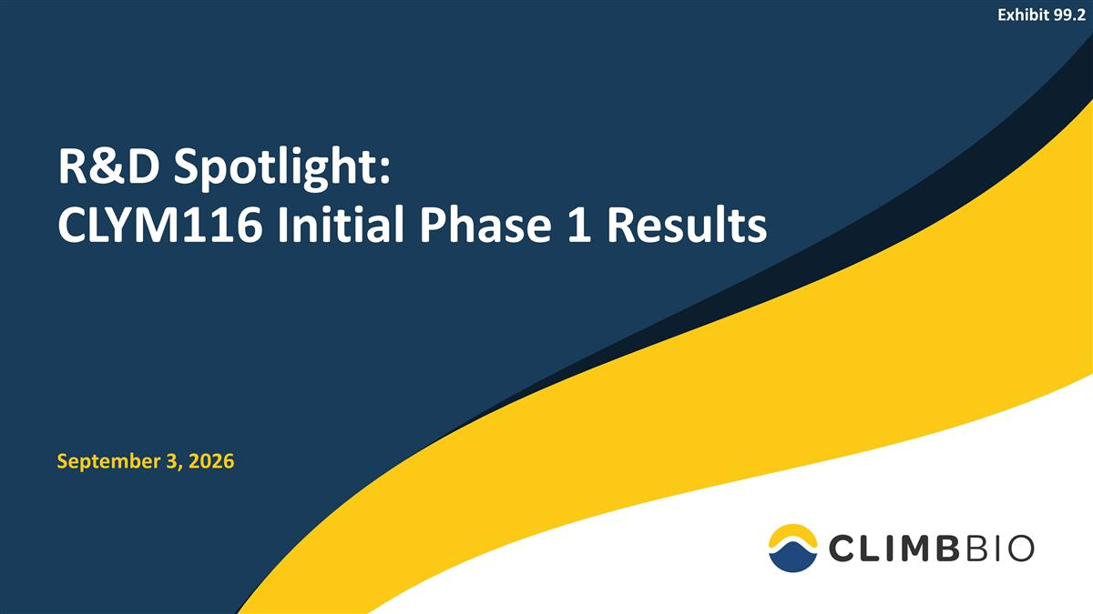
R&D Spotlight: CLYM116 Initial Phase 1 Results September 3, 2026 Exhibit 99.2

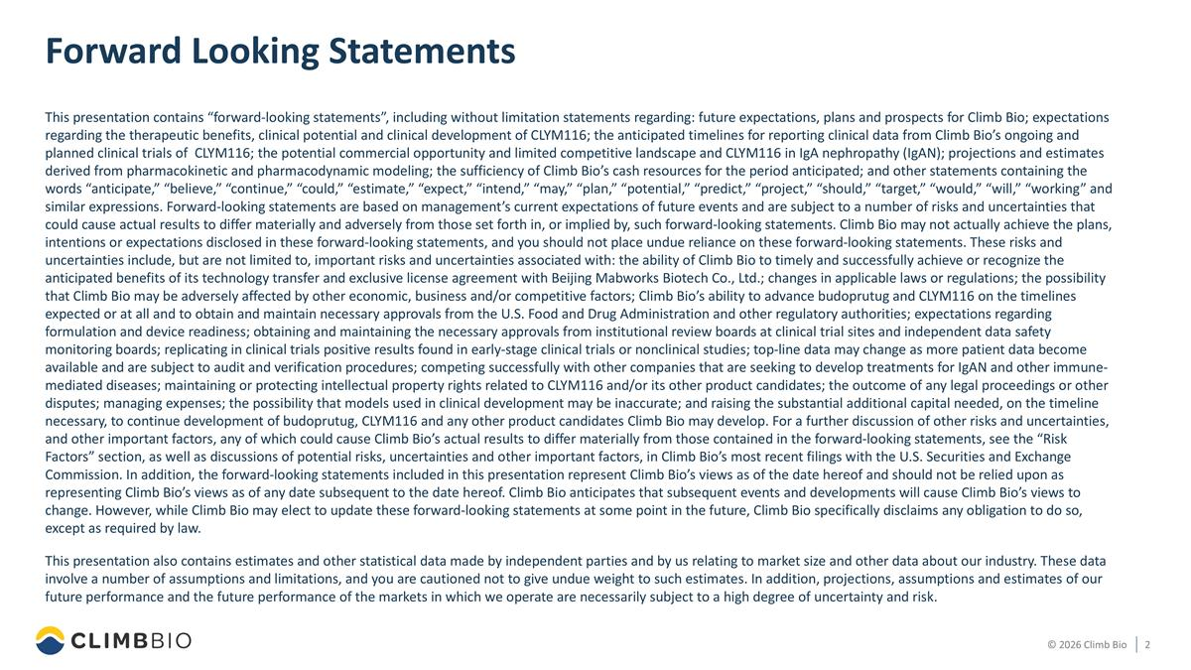
Forward Looking Statements This presentation contains “forward-looking statements”, including without limitation statements regarding: future expectations, plans and prospects for Climb Bio; expectations regarding the therapeutic benefits, clinical potential and clinical development of CLYM116; the anticipated timelines for reporting clinical data from Climb Bio’s ongoing and planned clinical trials of CLYM116; the potential commercial opportunity and limited competitive landscape and CLYM116 in IgA nephropathy (IgAN); projections and estimates derived from pharmacokinetic and pharmacodynamic modeling; the sufficiency of Climb Bio’s cash resources for the period anticipated; and other statements containing the words “anticipate,” “believe,” “continue,” “could,” “estimate,” “expect,” “intend,” “may,” “plan,” “potential,” “predict,” “project,” “should,” “target,” “would,” “will,” “working” and similar expressions. Forward-looking statements are based on management’s current expectations of future events and are subject to a number of risks and uncertainties that could cause actual results to differ materially and adversely from those set forth in, or implied by, such forward-looking statements. Climb Bio may not actually achieve the plans, intentions or expectations disclosed in these forward-looking statements, and you should not place undue reliance on these forward-looking statements. These risks and uncertainties include, but are not limited to, important risks and uncertainties associated with: the ability of Climb Bio to timely and successfully achieve or recognize the anticipated benefits of its technology transfer and exclusive license agreement with Beijing Mabworks Biotech Co., Ltd.; changes in applicable laws or regulations; the possibility that Climb Bio may be adversely affected by other economic, business and/or competitive factors; Climb Bio’s ability to advance budoprutug and CLYM116 on the timelines expected or at all and to obtain and maintain necessary approvals from the U.S. Food and Drug Administration and other regulatory authorities; expectations regarding formulation and device readiness; obtaining and maintaining the necessary approvals from institutional review boards at clinical trial sites and independent data safety monitoring boards; replicating in clinical trials positive results found in early-stage clinical trials or nonclinical studies; top-line data may change as more patient data become available and are subject to audit and verification procedures; competing successfully with other companies that are seeking to develop treatments for IgAN and other immune-mediated diseases; maintaining or protecting intellectual property rights related to CLYM116 and/or its other product candidates; the outcome of any legal proceedings or other disputes; managing expenses; the possibility that models used in clinical development may be inaccurate; and raising the substantial additional capital needed, on the timeline necessary, to continue development of budoprutug, CLYM116 and any other product candidates Climb Bio may develop. For a further discussion of other risks and uncertainties, and other important factors, any of which could cause Climb Bio’s actual results to differ materially from those contained in the forward-looking statements, see the “Risk Factors” section, as well as discussions of potential risks, uncertainties and other important factors, in Climb Bio’s most recent filings with the U.S. Securities and Exchange Commission. In addition, the forward-looking statements included in this presentation represent Climb Bio’s views as of the date hereof and should not be relied upon as representing Climb Bio’s views as of any date subsequent to the date hereof. Climb Bio anticipates that subsequent events and developments will cause Climb Bio’s views to change. However, while Climb Bio may elect to update these forward-looking statements at some point in the future, Climb Bio specifically disclaims any obligation to do so, except as required by law. This presentation also contains estimates and other statistical data made by independent parties and by us relating to market size and other data about our industry. These data involve a number of assumptions and limitations, and you are cautioned not to give undue weight to such estimates. In addition, projections, assumptions and estimates of our future performance and the future performance of the markets in which we operate are necessarily subject to a high degree of uncertainty and risk.

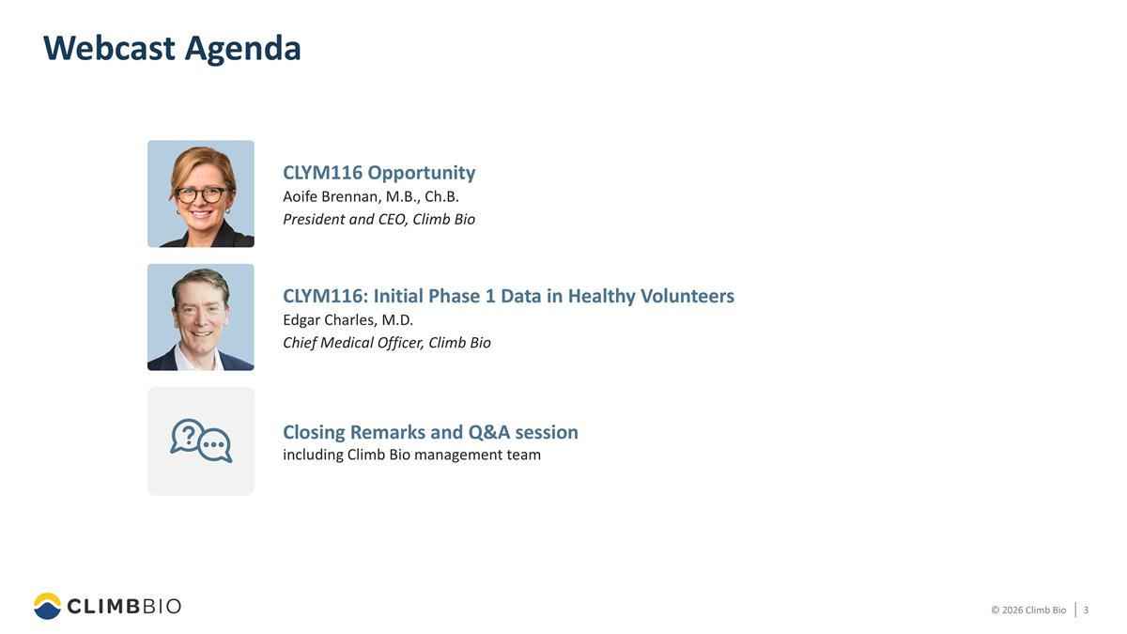
Webcast Agenda CLYM116: Initial Phase 1 Data in Healthy Volunteers Edgar Charles, M.D. Chief Medical Officer, Climb Bio Closing Remarks and Q&A session including Climb Bio management team CLYM116 Opportunity Aoife Brennan, M.B., Ch.B. President and CEO, Climb Bio

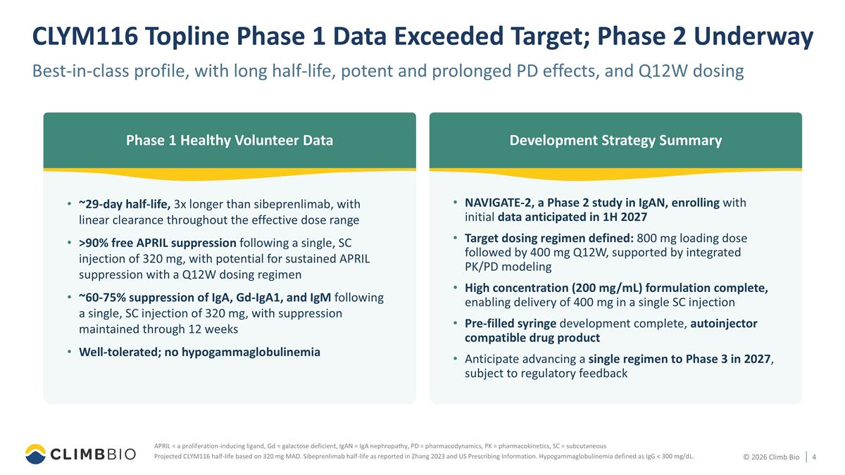
CLYM116 Topline Phase 1 Data Exceeded Target; Phase 2 Underway Best-in-class profile, with long half-life, potent and prolonged PD effects, and Q12W dosing APRIL = a proliferation-inducing ligand, Gd = galactose deficient, IgAN = IgA nephropathy, PD = pharmacodynamics, PK = pharmacokinetics, SC = subcutaneous Projected CLYM116 half-life based on 320 mg MAD. Sibeprenlimab half-life as reported in Zhang 2023 and US Prescribing Information. Hypogammaglobulinemia defined as IgG < 300 mg/dL. Phase 1 Healthy Volunteer Data ~29-day half-life, 3x longer than sibeprenlimab, with linear clearance throughout the effective dose range >90% free APRIL suppression following a single, SC injection of 320 mg, with potential for sustained APRIL suppression with a Q12W dosing regimen ~60-75% suppression of IgA, Gd-IgA1, and IgM following a single, SC injection of 320 mg, with suppression maintained through 12 weeks Well-tolerated; no hypogammaglobulinemia NAVIGATE-2, a Phase 2 study in IgAN, enrolling with initial data anticipated in 1H 2027 Target dosing regimen defined: 800 mg loading dose followed by 400 mg Q12W, supported by integrated PK/PD modeling High concentration (200 mg/mL) formulation complete, enabling delivery of 400 mg in a single SC injection Pre-filled syringe development complete, autoinjector compatible drug product Anticipate advancing a single regimen to Phase 3 in 2027, subject to regulatory feedback Development Strategy Summary

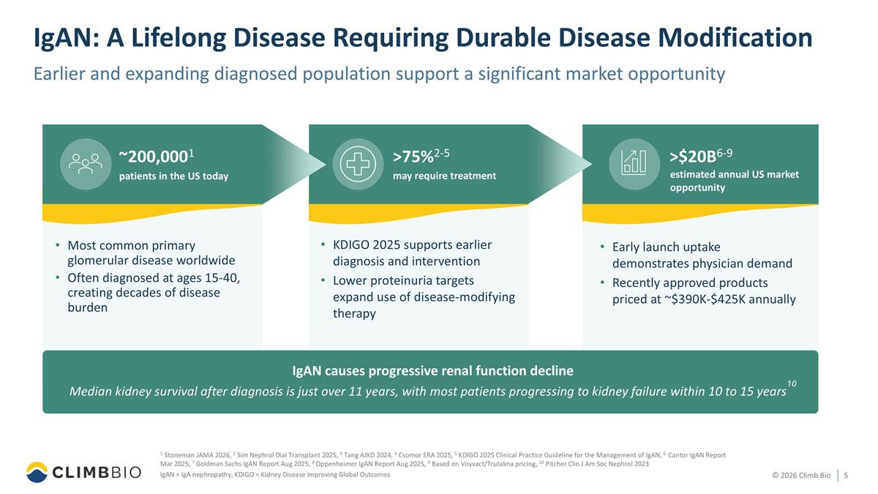
Early launch uptake demonstrates physician demand Recently approved products priced at ~$390K-$425K annually KDIGO 2025 supports earlier diagnosis and intervention Lower proteinuria targets expand use of disease-modifying therapy IgAN: A Lifelong Disease Requiring Durable Disease Modification Earlier and expanding diagnosed population support a significant market opportunity 1 Stoneman JAMA 2026, 2 Sim Nephrol Dial Transplant 2025, 3 Tang AJKD 2024, 4 Csomor ERA 2025, 5 KDIGO 2025 Clinical Practice Guideline for the Management of IgAN, 6 Cantor IgAN Report Mar 2025, 7 Goldman Sachs IgAN Report Aug 2025, 8 Oppenheimer IgAN Report Aug 2025, 9 Based on Voyxact/Trutakna pricing, 10 Pitcher Clin J Am Soc Nephrol 2023 IgAN = IgA nephropathy, KDIGO = Kidney Disease Improving Global Outcomes Most common primary glomerular disease worldwide Often diagnosed at ages 15-40, creating decades of disease burden IgAN causes progressive renal function decline Median kidney survival after diagnosis is just over 11 years, with most patients progressing to kidney failure within 10 to 15 years10 ~200,0001 patients in the US today >75%2-5 may require treatment >$20B6-9 estimated annual US market opportunity

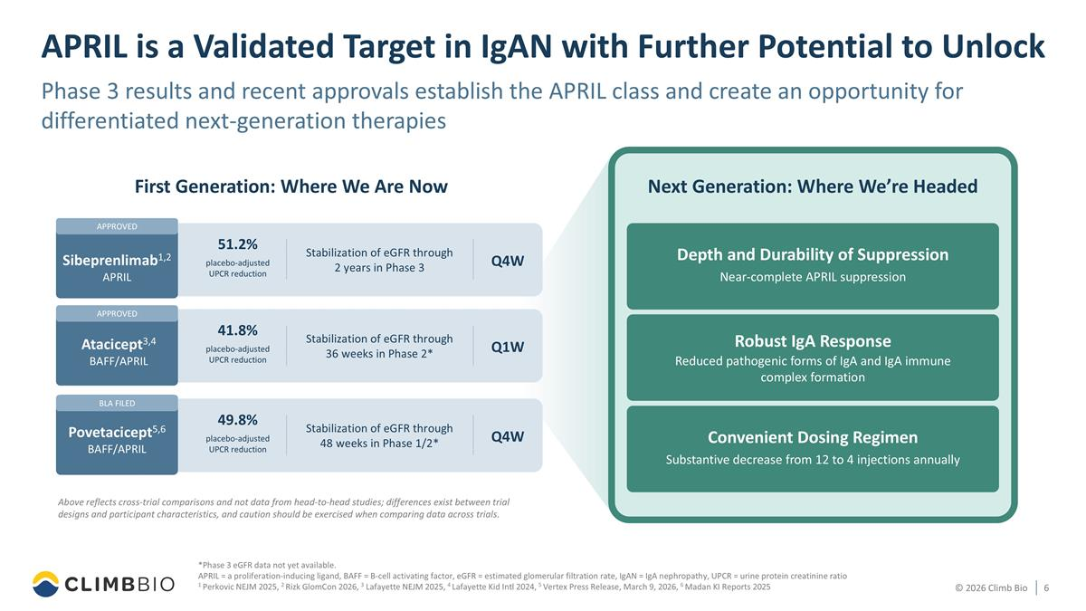
APPROVED BLA FILED @ APPROVED APRIL is a Validated Target in IgAN with Further Potential to Unlock Phase 3 results and recent approvals establish the APRIL class and create an opportunity for differentiated next-generation therapies *Phase 3 eGFR data not yet available. APRIL = a proliferation-inducing ligand, BAFF = B-cell activating factor, eGFR = estimated glomerular filtration rate, IgAN = IgA nephropathy, UPCR = urine protein creatinine ratio 1 Perkovic NEJM 2025, 2 Rizk GlomCon 2026, 3 Lafayette NEJM 2025, 4 Lafayette Kid Intl 2024, 5 Vertex Press Release, March 9, 2026, 6 Madan KI Reports 2025 First Generation: Where We Are Now Next Generation: Where We’re Headed Atacicept3,4 BAFF/APRIL Povetacicept5,6 BAFF/APRIL Sibeprenlimab1,2 APRIL Above reflects cross-trial comparisons and not data from head-to-head studies; differences exist between trial designs and participant characteristics, and caution should be exercised when comparing data across trials. 51.2% placebo-adjusted UPCR reduction 41.8% placebo-adjusted UPCR reduction Q1W Stabilization of eGFR through 36 weeks in Phase 2* Q4W Stabilization of eGFR through 2 years in Phase 3 49.8% placebo-adjusted UPCR reduction Q4W Stabilization of eGFR through 48 weeks in Phase 1/2* Depth and Durability of Suppression Near-complete APRIL suppression Robust IgA Response Reduced pathogenic forms of IgA and IgA immune complex formation Convenient Dosing Regimen Substantive decrease from 12 to 4 injections annually

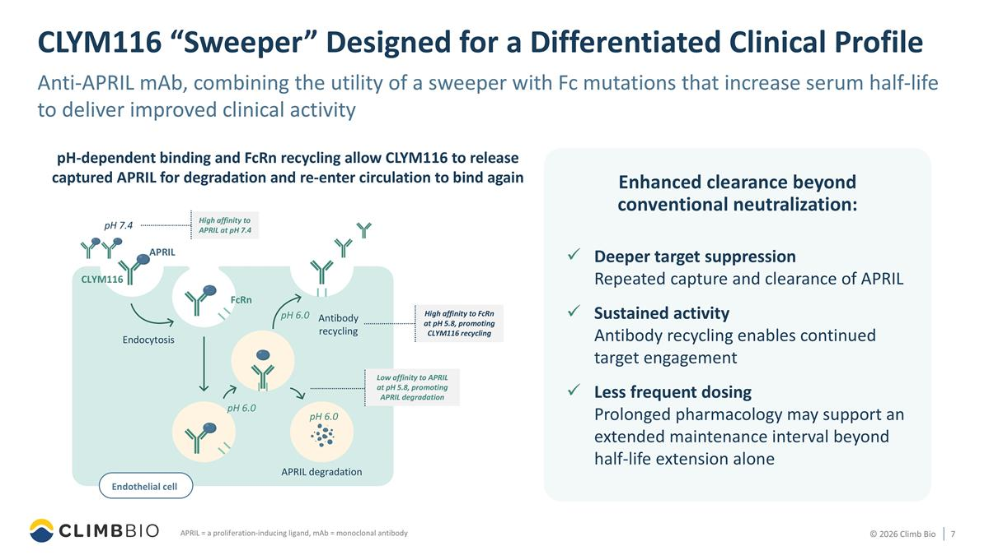
CLYM116 “Sweeper” Designed for a Differentiated Clinical Profile Anti-APRIL mAb, combining the utility of a sweeper with Fc mutations that increase serum half-life to deliver improved clinical activity APRIL = a proliferation-inducing ligand, mAb = monoclonal antibody Deeper target suppression Repeated capture and clearance of APRIL Sustained activity Antibody recycling enables continued target engagement Less frequent dosing Prolonged pharmacology may support an extended maintenance interval beyond half-life extension alone pH-dependent binding and FcRn recycling allow CLYM116 to release captured APRIL for degradation and re-enter circulation to bind again pH 6.0 Low affinity to APRIL at pH 5.8, promoting APRIL degradation APRIL Endocytosis APRIL degradation pH 6.0 pH 6.0 FcRn CLYM116 Antibody recycling High affinity to APRIL at pH 7.4 Endothelial cell pH 7.4 High affinity to FcRn at pH 5.8, promoting CLYM116 recycling Enhanced clearance beyond conventional neutralization:

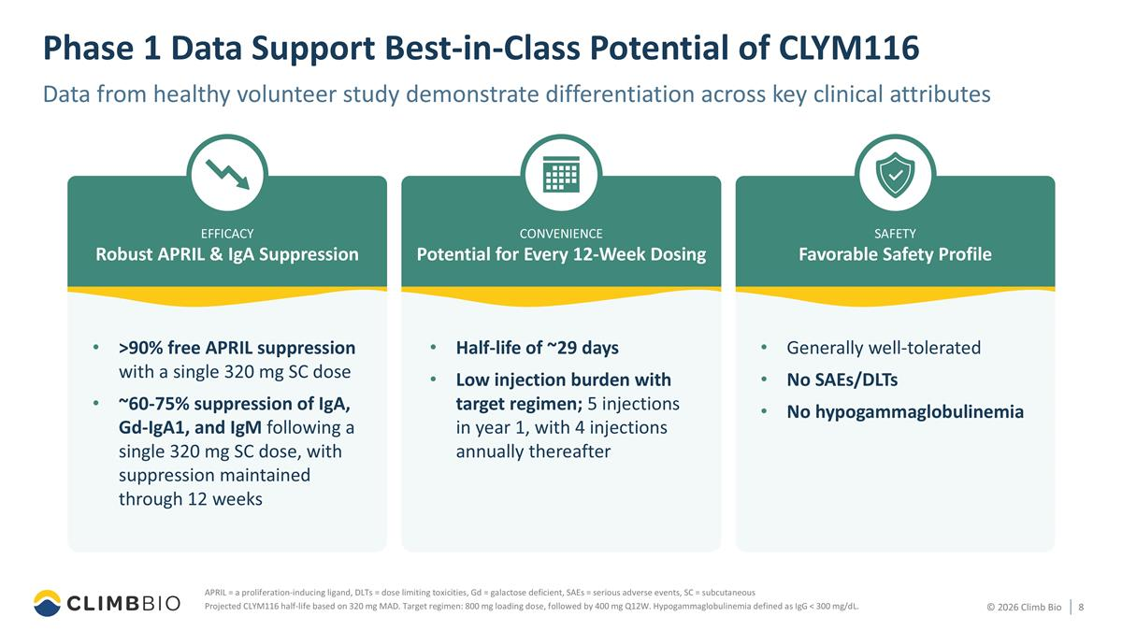
Phase 1 Data Support Best-in-Class Potential of CLYM116 Data from healthy volunteer study demonstrate differentiation across key clinical attributes APRIL = a proliferation-inducing ligand, DLTs = dose limiting toxicities, Gd = galactose deficient, SAEs = serious adverse events, SC = subcutaneous Projected CLYM116 half-life based on 320 mg MAD. Target regimen: 800 mg loading dose, followed by 400 mg Q12W. Hypogammaglobulinemia defined as IgG < 300 mg/dL. Favorable Safety Profile SAFETY Generally well-tolerated No SAEs/DLTs No hypogammaglobulinemia Potential for Every 12-Week Dosing CONVENIENCE Half-life of ~29 days Low injection burden with target regimen; 5 injections in year 1, with 4 injections annually thereafter Robust APRIL & IgA Suppression EFFICACY >90% free APRIL suppression with a single 320 mg SC dose ~60-75% suppression of IgA, Gd-IgA1, and IgM following a single 320 mg SC dose, with suppression maintained through 12 weeks

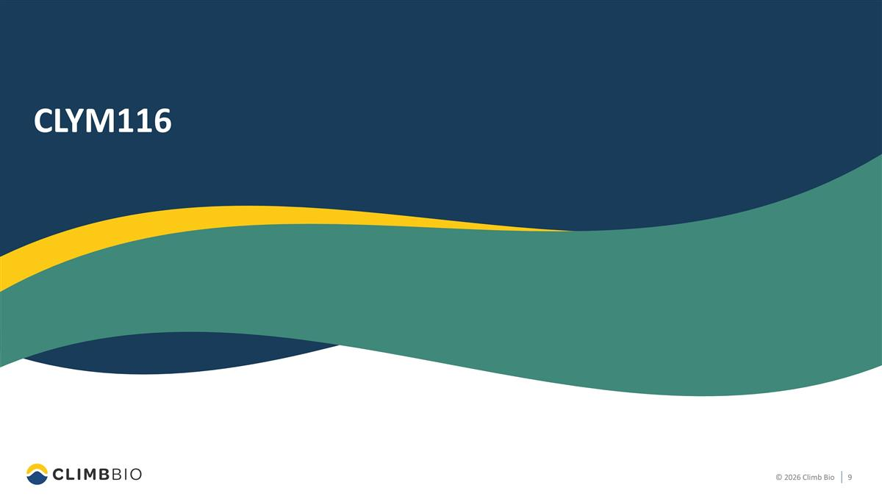
CLYM116

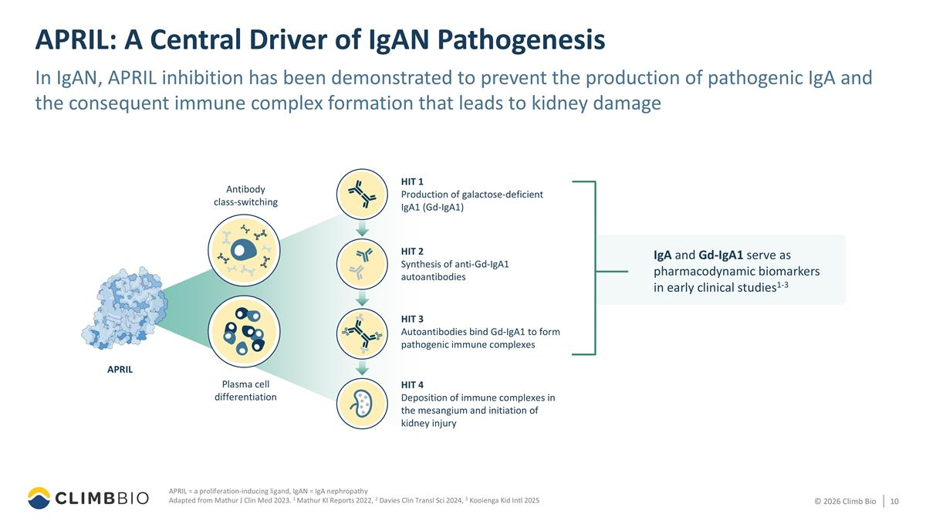
APRIL: A Central Driver of IgAN Pathogenesis In IgAN, APRIL inhibition has been demonstrated to prevent the production of pathogenic IgA and the consequent immune complex formation that leads to kidney damage APRIL = a proliferation-inducing ligand, IgAN = IgA nephropathy Adapted from Mathur J Clin Med 2023. 1 Mathur KI Reports 2022, 2 Davies Clin Transl Sci 2024, 3 Kooienga Kid Intl 2025 HIT 1 Production of galactose-deficient IgA1 (Gd-IgA1) HIT 2 Synthesis of anti-Gd-IgA1 autoantibodies HIT 3 Autoantibodies bind Gd-IgA1 to form pathogenic immune complexes HIT 4 Deposition of immune complexes in the mesangium and initiation of kidney injury Plasma cell differentiation Antibody class-switching APRIL IgA and Gd-IgA1 serve as pharmacodynamic biomarkers in early clinical studies1-3

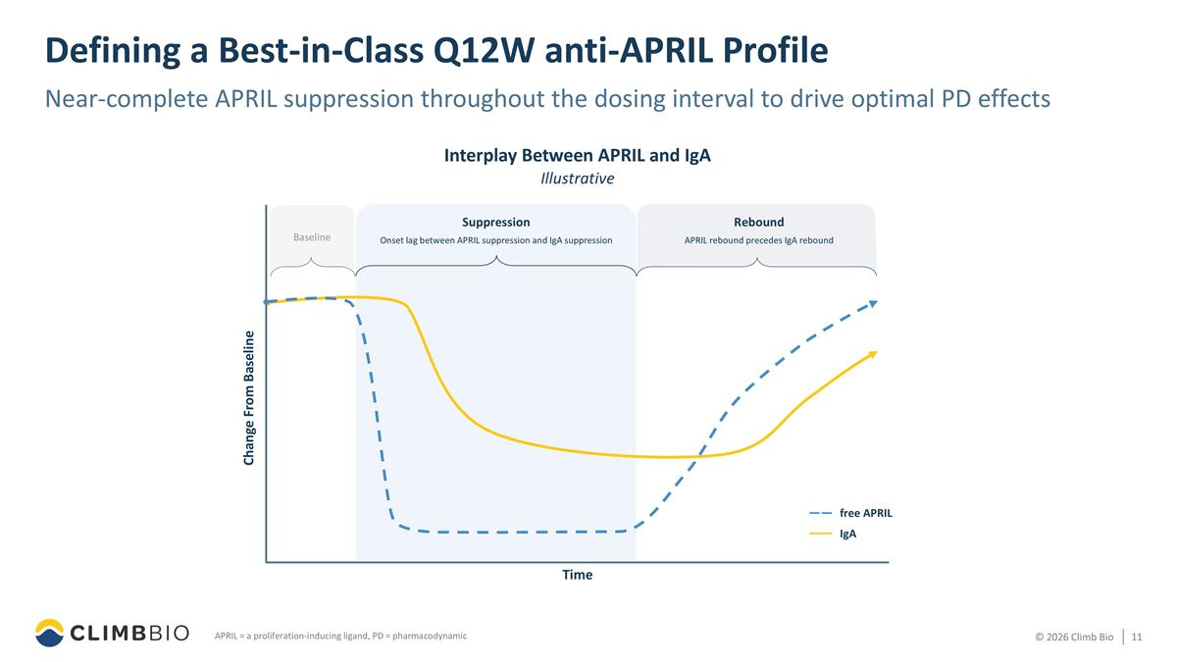
Defining a Best-in-Class Q12W anti-APRIL Profile Near-complete APRIL suppression throughout the dosing interval to drive optimal PD effects APRIL = a proliferation-inducing ligand, PD = pharmacodynamic Interplay Between APRIL and IgA Illustrative Suppression Onset lag between APRIL suppression and IgA suppression Change From Baseline Time Rebound APRIL rebound precedes IgA rebound Baseline IgA free APRIL

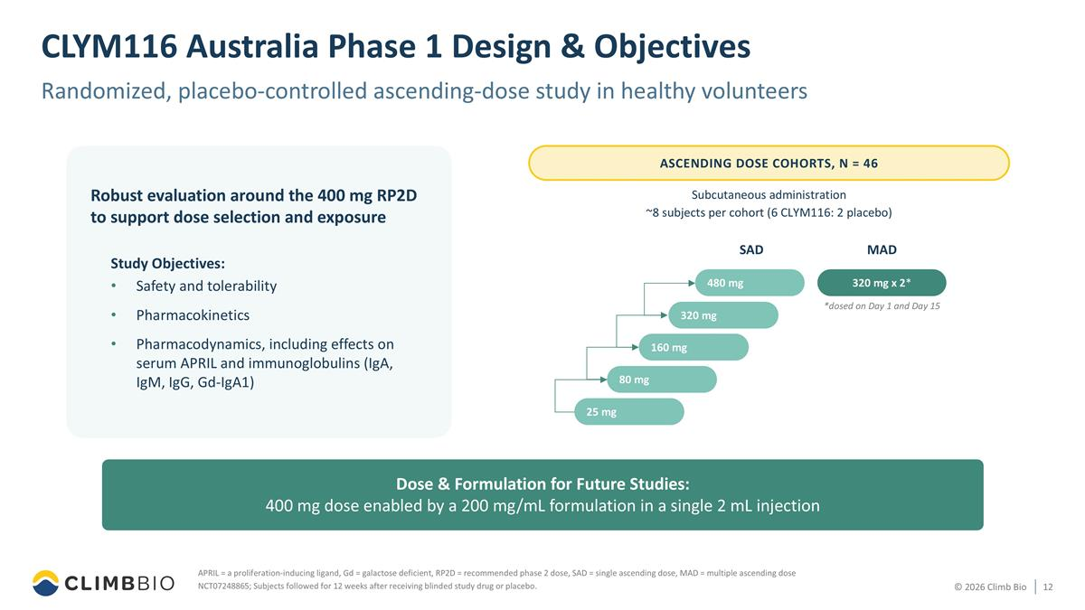
CLYM116 Australia Phase 1 Design & Objectives Randomized, placebo-controlled ascending-dose study in healthy volunteers APRIL = a proliferation-inducing ligand, Gd = galactose deficient, RP2D = recommended phase 2 dose, SAD = single ascending dose, MAD = multiple ascending dose NCT07248865; Subjects followed for 12 weeks after receiving blinded study drug or placebo. Study Objectives: Safety and tolerability Pharmacokinetics Pharmacodynamics, including effects on serum APRIL and immunoglobulins (IgA, IgM, IgG, Gd-IgA1) Robust evaluation around the 400 mg RP2D to support dose selection and exposure ASCENDING DOSE COHORTS, N = 46 Subcutaneous administration ~8 subjects per cohort (6 CLYM116: 2 placebo) 320mg x 2* SAD MAD 80 mg 160 mg 25 mg 320 mg 480 mg 320 mg x 2* *dosed on Day 1 and Day 15 Dose & Formulation for Future Studies: 400 mg dose enabled by a 200 mg/mL formulation in a single 2 mL injection

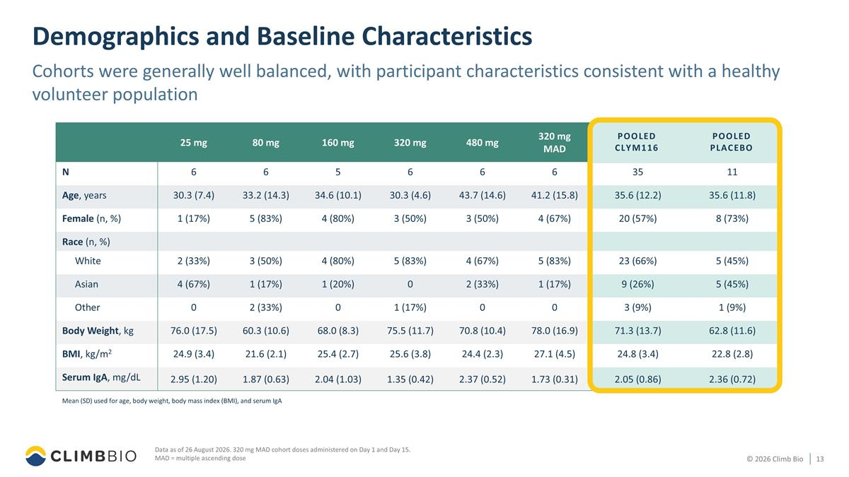
25 mg 80 mg 160 mg 320 mg 480 mg 320 mg MAD Pooled CLYM116 Pooled Placebo N 6 6 5 6 6 6 35 11 Age, years 30.3 (7.4) 33.2 (14.3) 34.6 (10.1) 30.3 (4.6) 43.7 (14.6) 41.2 (15.8) 35.6 (12.2) 35.6 (11.8) Female (n, %) 1 (17%) 5 (83%) 4 (80%) 3 (50%) 3 (50%) 4 (67%) 20 (57%) 8 (73%) Race (n, %) White 2 (33%) 3 (50%) 4 (80%) 5 (83%) 4 (67%) 5 (83%) 23 (66%) 5 (45%) Asian 4 (67%) 1 (17%) 1 (20%) 0 2 (33%) 1 (17%) 9 (26%) 5 (45%) Other 0 2 (33%) 0 1 (17%) 0 0 3 (9%) 1 (9%) Body Weight, kg 76.0 (17.5) 60.3 (10.6) 68.0 (8.3) 75.5 (11.7) 70.8 (10.4) 78.0 (16.9) 71.3 (13.7) 62.8 (11.6) BMI, kg/m2 24.9 (3.4) 21.6 (2.1) 25.4 (2.7) 25.6 (3.8) 24.4 (2.3) 27.1 (4.5) 24.8 (3.4) 22.8 (2.8) Serum IgA, mg/dL 2.95 (1.20) 1.87 (0.63) 2.04 (1.03) 1.35 (0.42) 2.37 (0.52) 1.73 (0.31) 2.05 (0.86) 2.36 (0.72) Demographics and Baseline Characteristics Cohorts were generally well balanced, with participant characteristics consistent with a healthy volunteer population Data as of 26 August 2026. 320 mg MAD cohort doses administered on Day 1 and Day 15. MAD = multiple ascending dose POOLED CLYM116 POOLED PLACEBO Mean (SD) used for age, body weight, body mass index (BMI), and serum IgA

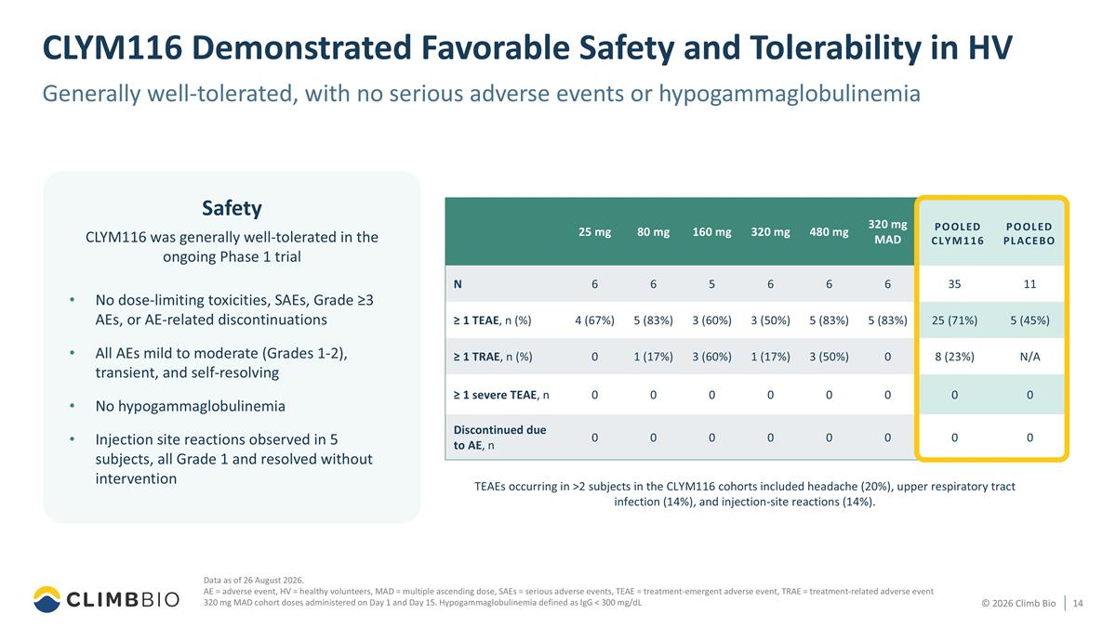
25 mg 80 mg 160 mg 320 mg 480 mg 320 mg MAD Pooled CLYM116 Pooled Placebo N 6 6 5 6 6 6 35 11 ≥ 1 TEAE, n (%) 4 (67%) 5 (83%) 3 (60%) 3 (50%) 5 (83%) 5 (83%) 25 (71%) 5 (45%) ≥ 1 TRAE, n (%) 0 1 (17%) 3 (60%) 1 (17%) 3 (50%) 0 8 (23%) N/A ≥ 1 severe TEAE, n 0 0 0 0 0 0 0 0 Discontinued due to AE, n 0 0 0 0 0 0 0 0 CLYM116 Demonstrated Favorable Safety and Tolerability in HV Generally well-tolerated, with no serious adverse events or hypogammaglobulinemia Data as of 26 August 2026. AE = adverse event, HV = healthy volunteers, MAD = multiple ascending dose, SAEs = serious adverse events, TEAE = treatment-emergent adverse event, TRAE = treatment-related adverse event 320 mg MAD cohort doses administered on Day 1 and Day 15. Hypogammaglobulinemia defined as IgG < 300 mg/dL No dose-limiting toxicities, SAEs, Grade ≥3 AEs, or AE-related discontinuations All AEs mild to moderate (Grades 1-2), transient, and self-resolving No hypogammaglobulinemia Injection site reactions observed in 5 subjects, all Grade 1 and resolved without intervention TEAEs occurring in >2 subjects in the CLYM116 cohorts included headache (20%), upper respiratory tract infection (14%), and injection-site reactions (14%). POOLED CLYM116 POOLED PLACEBO Safety CLYM116 was generally well-tolerated in the ongoing Phase 1 trial

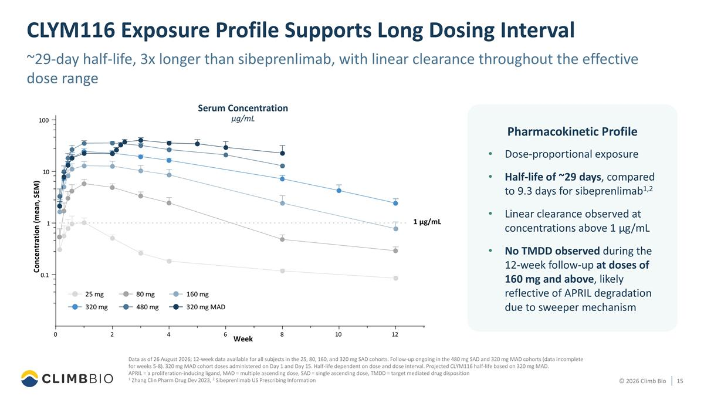
CLYM116 Exposure Profile Supports Long Dosing Interval Data as of 26 August 2026; 12-week data available for all subjects in the 25, 80, 160, and 320 mg SAD cohorts. Follow-up ongoing in the 480 mg SAD and 320 mg MAD cohorts (data incomplete for weeks 5-8). 320 mg MAD cohort doses administered on Day 1 and Day 15. Half-life dependent on dose and dose interval. Projected CLYM116 half-life based on 320 mg MAD. APRIL = a proliferation-inducing ligand, MAD = multiple ascending dose, SAD = single ascending dose, TMDD = target mediated drug disposition 1 Zhang Clin Pharm Drug Dev 2023, 2 Sibeprenlimab US Prescribing Information ~29-day half-life, 3x longer than sibeprenlimab, with linear clearance throughout the effective dose range Week Dose-proportional exposure Half-life of ~29 days, compared to 9.3 days for sibeprenlimab1,2 Linear clearance observed at concentrations above 1 µg/mL No TMDD observed during the 12-week follow-up at doses of 160 mg and above, likely reflective of APRIL degradation due to sweeper mechanism Pharmacokinetic Profile 25 mg 480 mg 160 mg 80 mg 320 mg 320 mg MAD Concentration (mean, SEM) Serum Concentration μg/mL 0 2 4 6 8 10 12 0.1 1 10 100 1 μg/mL

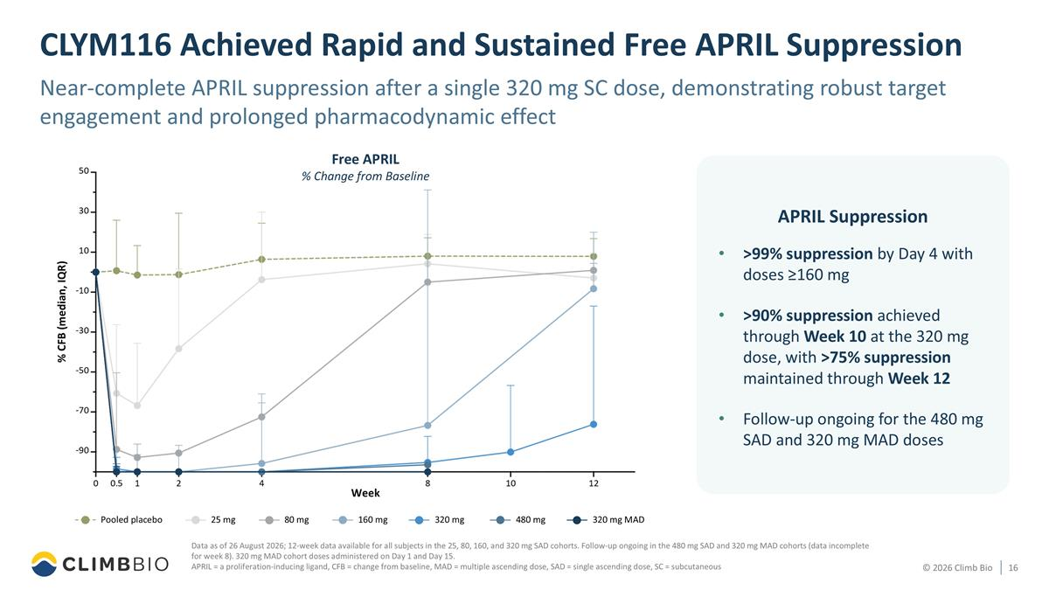
CLYM116 Achieved Rapid and Sustained Free APRIL Suppression Near-complete APRIL suppression after a single 320 mg SC dose, demonstrating robust target engagement and prolonged pharmacodynamic effect Data as of 26 August 2026; 12-week data available for all subjects in the 25, 80, 160, and 320 mg SAD cohorts. Follow-up ongoing in the 480 mg SAD and 320 mg MAD cohorts (data incomplete for week 8). 320 mg MAD cohort doses administered on Day 1 and Day 15. APRIL = a proliferation-inducing ligand, CFB = change from baseline, MAD = multiple ascending dose, SAD = single ascending dose, SC = subcutaneous >99% suppression by Day 4 with doses ≥160 mg >90% suppression achieved through Week 10 at the 320 mg dose, with >75% suppression maintained through Week 12 Follow-up ongoing for the 480 mg SAD and 320 mg MAD doses APRIL Suppression % CFB (median, IQR) Week Free APRIL % Change from Baseline 320 mg Pooled placebo 80 mg 320 mg MAD 25 mg 160 mg 480 mg

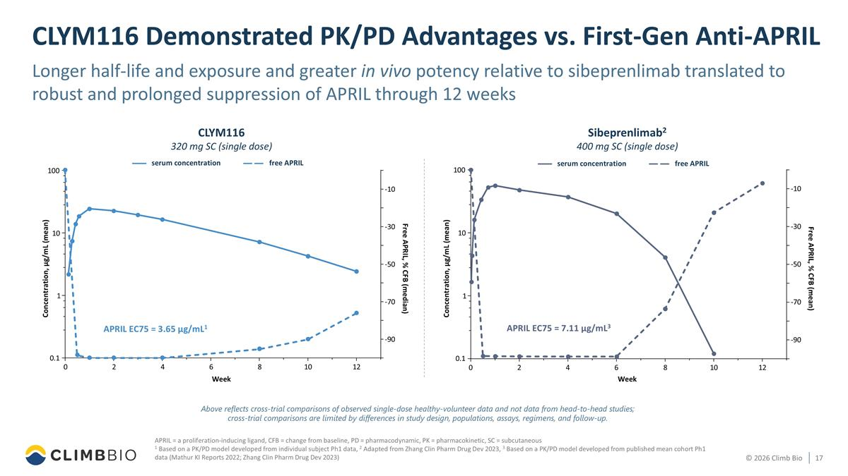
Above reflects cross-trial comparisons of observed single-dose healthy-volunteer data and not data from head-to-head studies; cross-trial comparisons are limited by differences in study design, populations, assays, regimens, and follow-up. APRIL = a proliferation-inducing ligand, CFB = change from baseline, PD = pharmacodynamic, PK = pharmacokinetic, SC = subcutaneous 1 Based on a PK/PD model developed from individual subject Ph1 data, 2 Adapted from Zhang Clin Pharm Drug Dev 2023, 3 Based on a PK/PD model developed from published mean cohort Ph1 data (Mathur KI Reports 2022; Zhang Clin Pharm Drug Dev 2023) CLYM116 Demonstrated PK/PD Advantages vs. First-Gen Anti-APRIL Longer half-life and exposure and greater in vivo potency relative to sibeprenlimab translated to robust and prolonged suppression of APRIL through 12 weeks 0 2 4 6 8 10 12 0.1 1 10 100 -90 -70 -50 -30 -10 APRIL EC75 = 3.65 µg/mL1 Concentration, µg/mL (mean) Free APRIL, % CFB (median) Week CLYM116 320 mg SC (single dose) serum concentration free APRIL 0 2 4 6 8 10 12 0.1 1 10 100 -90 -70 -50 -30 -10 APRIL EC75 = 7.11 µg/mL3 Concentration, µg/mL (mean) Free APRIL, % CFB (mean) Week Sibeprenlimab2 400 mg SC (single dose) serum concentration free APRIL

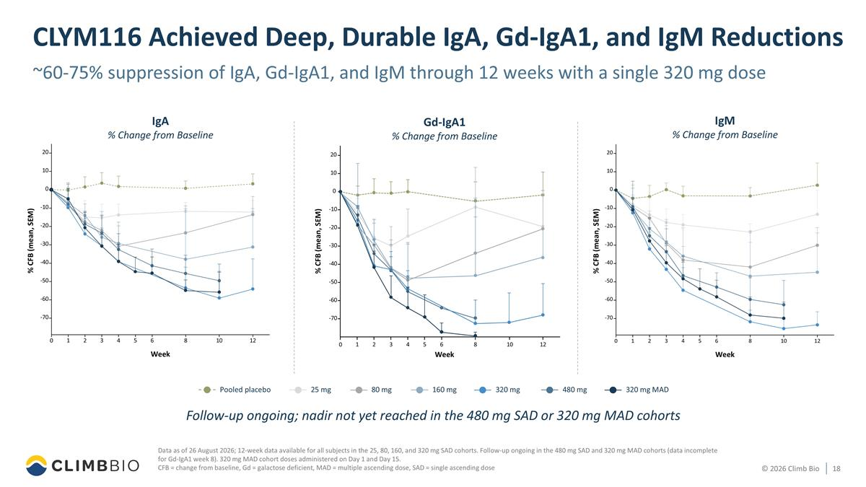
~60-75% suppression of IgA, Gd-IgA1, and IgM through 12 weeks with a single 320 mg dose Data as of 26 August 2026; 12-week data available for all subjects in the 25, 80, 160, and 320 mg SAD cohorts. Follow-up ongoing in the 480 mg SAD and 320 mg MAD cohorts (data incomplete for Gd-IgA1 week 8). 320 mg MAD cohort doses administered on Day 1 and Day 15. CFB = change from baseline, Gd = galactose deficient, MAD = multiple ascending dose, SAD = single ascending dose CLYM116 Achieved Deep, Durable IgA, Gd-IgA1, and IgM Reductions 320 mg Pooled placebo 80 mg 320 mg MAD 25 mg 160 mg 480 mg IgA % Change from Baseline % CFB (mean, SEM) Week 0 2 4 6 8 10 12 1 3 5 -70 -60 -50 -40 -30 -20 -10 0 10 20 IgM % Change from Baseline % CFB (mean, SEM) Week Gd-IgA1 % Change from Baseline % CFB (mean, SEM) Week 0 2 4 8 12 1 3 6 5 10 -70 -60 -50 -40 -30 -20 -10 0 10 20 Follow-up ongoing; nadir not yet reached in the 480 mg SAD or 320 mg MAD cohorts

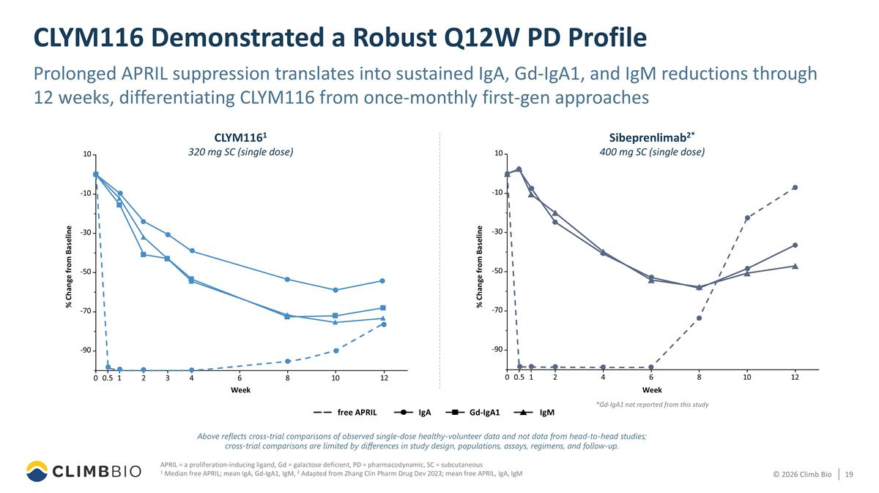
CLYM116 Demonstrated a Robust Q12W PD Profile Prolonged APRIL suppression translates into sustained IgA, Gd-IgA1, and IgM reductions through 12 weeks, differentiating CLYM116 from once-monthly first-gen approaches APRIL = a proliferation-inducing ligand, Gd = galactose deficient, PD = pharmacodynamic, SC = subcutaneous 1 Median free APRIL; mean IgA, Gd-IgA1, IgM, 2 Adapted from Zhang Clin Pharm Drug Dev 2023; mean free APRIL, IgA, IgM Above reflects cross-trial comparisons of observed single-dose healthy-volunteer data and not data from head-to-head studies; cross-trial comparisons are limited by differences in study design, populations, assays, regimens, and follow-up. IgA IgM free APRIL Gd-IgA1 *Gd-IgA1 not reported from this study Sibeprenlimab2* 400 mg SC (single dose) % Change from Baseline Week 4 -90 -70 -50 -30 -10 10 0 0. 5 1 2 6 8 10 12 CLYM1161 320 mg SC (single dose) Week % Change from Baseline 0 0. 5 1 -70 -50 -30 -10 10 2 3 4 8 10 12 -90 6

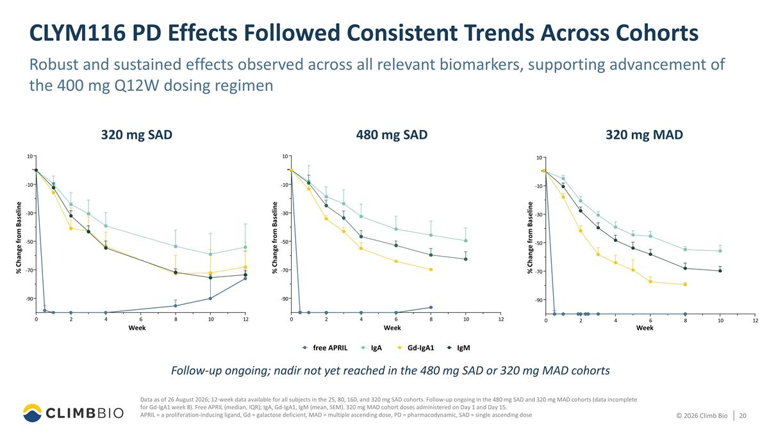
CLYM116 PD Effects Followed Consistent Trends Across Cohorts Data as of 26 August 2026; 12-week data available for all subjects in the 25, 80, 160, and 320 mg SAD cohorts. Follow-up ongoing in the 480 mg SAD and 320 mg MAD cohorts (data incomplete for Gd-IgA1 week 8). Free APRIL (median, IQR); IgA, Gd-IgA1, IgM (mean, SEM). 320 mg MAD cohort doses administered on Day 1 and Day 15. APRIL = a proliferation-inducing ligand, Gd = galactose deficient, MAD = multiple ascending dose, PD = pharmacodynamic, SAD = single ascending dose Robust and sustained effects observed across all relevant biomarkers, supporting advancement of the 400 mg Q12W dosing regimen IgA Gd-IgA1 IgM free APRIL 320 mg SAD 0 2 4 6 8 10 12 -90 -70 -50 -30 -10 10 Week % Change from Baseline 480 mg SAD Week 0 2 4 6 8 10 12 -90 -70 -50 -30 -10 10 % Change from Baseline 320 mg MAD 0 2 4 6 8 10 12 -90 -70 -50 -30 -10 10 Week % Change from Baseline Follow-up ongoing; nadir not yet reached in the 480 mg SAD or 320 mg MAD cohorts

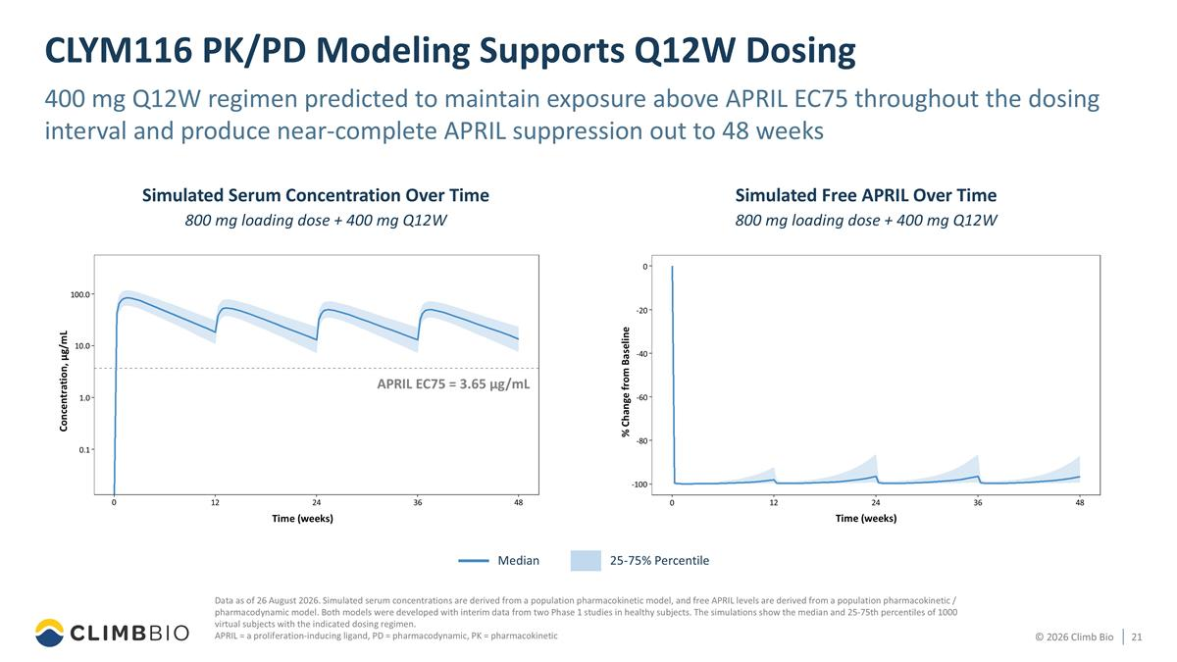
CLYM116 PK/PD Modeling Supports Q12W Dosing 400 mg Q12W regimen predicted to maintain exposure above APRIL EC75 throughout the dosing interval and produce near-complete APRIL suppression out to 48 weeks Data as of 26 August 2026. Simulated serum concentrations are derived from a population pharmacokinetic model, and free APRIL levels are derived from a population pharmacokinetic / pharmacodynamic model. Both models were developed with interim data from two Phase 1 studies in healthy subjects. The simulations show the median and 25-75th percentiles of 1000 virtual subjects with the indicated dosing regimen. APRIL = a proliferation-inducing ligand, PD = pharmacodynamic, PK = pharmacokinetic APRIL EC75 = 3.65 µg/mL Median 25-75% Percentile Simulated Serum Concentration Over Time 800 mg loading dose + 400 mg Q12W Time (weeks) Concentration, µg/mL 0 12 24 36 48 0.1 1.0 10.0 100.0 -100 Simulated Free APRIL Over Time 800 mg loading dose + 400 mg Q12W Time (weeks) 0 12 24 36 48 -80 -60 -40 -20 0 % Change from Baseline APRIL EC75 = 3.65 µg/mL

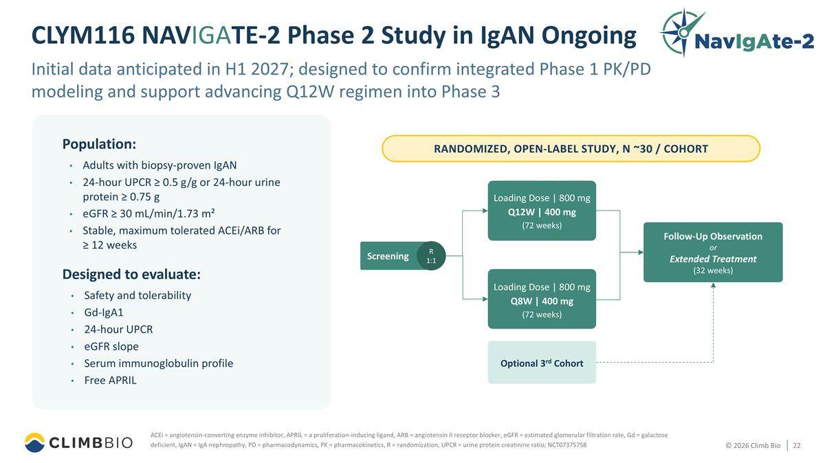
Initial data anticipated in H1 2027; designed to confirm integrated Phase 1 PK/PD modeling and support advancing Q12W regimen into Phase 3 CLYM116 NAVIGATE-2 Phase 2 Study in IgAN Ongoing Population: Adults with biopsy-proven IgAN 24-hour UPCR ≥ 0.5 g/g or 24-hour urine protein ≥ 0.75 g eGFR ≥ 30 mL/min/1.73 m² Stable, maximum tolerated ACEi/ARB for ≥ 12 weeks Designed to evaluate: Safety and tolerability Gd-IgA1 24-hour UPCR eGFR slope Serum immunoglobulin profile Free APRIL ACEi = angiotensin-converting enzyme inhibitor, APRIL = a proliferation-inducing ligand, ARB = angiotensin II receptor blocker, eGFR = estimated glomerular filtration rate, Gd = galactose deficient, IgAN = IgA nephropathy, PD = pharmacodynamics, PK = pharmacokinetics, R = randomization, UPCR = urine protein creatinine ratio; NCT07375758 RANDOMIZED, OPEN-LABEL STUDY, N ~30 / COHORT Screening Loading Dose | 800 mg Q12W | 400 mg (72 weeks) Loading Dose | 800 mg Q8W | 400 mg (72 weeks) Follow-Up Observation or Extended Treatment (32 weeks) Optional 3rd Cohort R 1:1

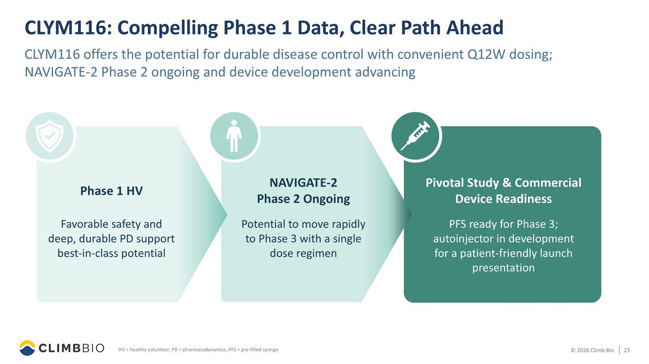
CLYM116: Compelling Phase 1 Data, Clear Path Ahead CLYM116 offers the potential for durable disease control with convenient Q12W dosing; NAVIGATE-2 Phase 2 ongoing and device development advancing HV = healthy volunteer, PD = pharmacodynamics, PFS = pre-filled syringe Pivotal Study & Commercial Device Readiness Phase 1 HV Favorable safety and deep, durable PD support best-in-class potential PFS ready for Phase 3; autoinjector in development for a patient-friendly launch presentation NAVIGATE-2 Phase 2 Ongoing Potential to move rapidly to Phase 3 with a single dose regimen


Closing Remarks

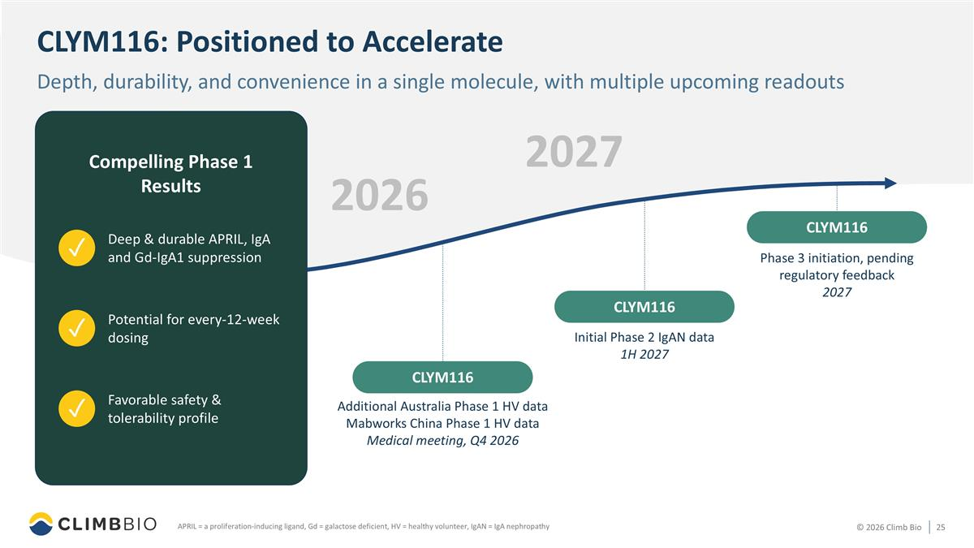
CLYM116: Positioned to Accelerate Depth, durability, and convenience in a single molecule, with multiple upcoming readouts APRIL = a proliferation-inducing ligand, Gd = galactose deficient, HV = healthy volunteer, IgAN = IgA nephropathy 2026 CLYM116 Compelling Phase 1 Results Initial Phase 2 IgAN data 1H 2027 Additional Australia Phase 1 HV data Mabworks China Phase 1 HV data Medical meeting, Q4 2026 CLYM116 2027 Potential for every-12-week dosing ✓ Deep & durable APRIL, IgA and Gd-IgA1 suppression ✓ Favorable safety & tolerability profile ✓ CLYM116 Phase 3 initiation, pending regulatory feedback 2027


Q&A Session Aoife Brennan, M.B., Ch.B. President and CEO, Climb Bio Edgar Charles, M.D. Chief Medical Officer, Climb Bio Perrin Wilson, Ph.D. Chief Business Officer, Climb Bio Susan Altschuller, Ph.D., MBA Chief Financial Officer, Climb Bio

